HARDWARE FOCUS – PROJECT NO. 7
Automated Verification Project
– Group 4 –
Nguyen Minh Duc – Tran Minh Tuan

Table of Contents
Table of Contents 2
Contribution 3
List of Figures 4
List of Tables 5
Introduction 6
1.1. Background 6
1.2. Feature Summary 6
1.3. Objectives 6
1.4. Scope 6
I. Diagram 7
2.1. Block Diagram 7
2.2. Automated Verification Functional Diagram 14
2.3. Testbench Signal and Register Table 16
II. Module Specifications 17
3.1. RISC-V Pipeline DUT 17
3.2. Scoreboard 17
3.3. Tohost WRITE Monitor Interface 17
3.4. Memory Initialization Interface 18
2.5. Trace Logger Interface 19
3.6. Functional Coverage 19
3.7. Previous Destination Register 20
3.8. Hierarchical Monitored DUT Signals 20
3.9. Simulation Control 21
III. Verification Strategy 21
5.1. Regression Flow 21
5.2. Verification Matrix 22
5.3. Coverage Plan 22
IV. PASS/FAIL Criteria 22
6.1. PASS Criteria 22
6.2. FAIL Criteria 23
V. Result 23
VI. Deliverables 25
References 26

Contribution
- Group Contribution
Date | Author | Change Description | Status | Contribution
August 1st, 2026 | Nguyen Minh Duc | Design a full specification for the final project based on the final one-page spec and proposal. | Draft | 50%
August 17th, 2026 | Tran Minh Tuan | Add real RTL ports, register offsets, and waveform images. | Draft | 50%
September 12th, 2026 | Group 4 | Release for final review, demo, and presentation. | Release

List of Figures
Figure 1. Full Pipeline RISC-V CPU Diagram 7
Figure 2. Fetch State Block Diagram 8
Figure 3. Decode State Block Diagram 9
Figure 4. Execute State Block Diagram 11
Figure 5. Memory State Block Diagram 12
Figure 6. Write Back State Block Diagram 13
Figure 7. Automated Verification Functional Diagram 14
Figure 8. Testbench PASS Result Simulation Log (1) 23
Figure 9. Testbench PASS Result Simulation Log (2) 24
Figure 10. Testbench FAIL Result Simulation Log 25

List of Tables
Table 1. Group Contribution 6
Table 2. Top-Level Pipelined RISC-V CPU Port Description 7
Table 3. Top-Level Pipelined RISC-V CPU Registers Description 7
Table 4. IF_ID Register Control Inputs 9
Table 5. IF_ID Register Port Description 9
Table 6. IF_ID Register Pipeline Event Behavior 9
Table 7. ID_EX Register Datapath fields 10
Table 8. ID_EX Register Instruction-decoding fields 11
Table 9. ID_EX Register and Writeback controls 11
Table 10. ID_EX Register ALU controls 11
Table 11. ID_EX Register Memory controls 11
Table 12. ID_EX Register Branch and Jump controls 11
Table 13. ID_EX Register Bubble control 11
Table 14. EX_MEM Register Datapath fields 12
Table 15. MEM_WB Register Datapath fields 13
Table 16. MEM_WB Register Writeback selection 14
Table 17. MEM_WB Register Port Description 14
Table 18. Testbench Top-Level Port Description 16
Table 19. Testbench File Input/Output Description 16
Table 20. Testbench Signal and Register Description 16
Table 21. RISCV_pipeline DUT Port Description 18
Table 22. Scoreboard Port Description 18
Table 23. Tohost WRITE Monitor Interface Port Description 18
Table 24. Tohost Decision Behavior 19
Table 25. Tohost Configuration Description 19
Table 26. Memory Initialization Interface Input File Description 19
Table 27. Trace Logger Interface Input Signals Description 20
Table 28. Trace Logger Output Description 20
Table 29. Trace Logger File-descriptor 20
Table 30. Functional Coverage Signal Purpose 20
Table 31. Coverage-derived Field Description 21
Table 32. Functional Coverage Point Description 21
Table 33. Opcode Coverage Bins 21
Table 34. Previous Destination Register Description 21
Table 35. Hierarchical Monitored DUT Signals Description 21
Table 36. Simulation Control Behavior 22
Table 37. Verification Matrix 23

Introduction

1.1. Background
This project specifies an automated verification environment for two RISC-V RV32I processor implementations: a single-cycle processor and a 5-stage pipelined processor. The single-cycle core is used as a simple baseline target for ISA correctness, while the pipelined core adds microarchitectural behavior including forwarding, stall insertion, branch prediction, flush control, misaligned memory handling, and debug or commit signal visibility. In this project, our group chose the 5-stage pipelined processor
The verification environment uses Verilog-based register-transfer level (RTL) modules and SystemVerilog testbench components and Makefile-based automation to compile RISC-V assembly programs into HEX files, load them into instruction memory, execute simulations for both DUTs, check architectural results, collect logs and waveforms, and summarize PASS/FAIL results.

1.2. Feature Summary
- Supports both single-cycle and 5-stage pipelined RV32I DUT configurations.
- Runs directed ISA tests and additional source/destination operand corner cases.
- Checks register write-back, memory read/write behavior, PC updates, branch/jump behavior, and final tohost signature.
- For the pipelined DUT, checks forwarding, load-use stalls, load-to-branch/jump stalls, branch prediction or flush behavior, PC recovery, and misaligned memory access behavior.
- Generates repeatable PASS/FAIL summaries, detailed mismatch logs, waveform outputs, coverage summaries, and performance statistics such as cycle count, instruction count, instructions per cycle (IPC), control instruction count, and branch misprediction count.

1.3. Objectives
- Create an automated flow that can run a regression suite on both RV32I implementations.
- Reduce manual waveform-only debugging by introducing clear checkers, expected-vs-actual comparisons, and failure messages.
- Keep the test program compact while maintaining meaningful fault-detection strength against injected RTL bugs.
- Produce final evidence including logs, waveform samples, regression summary, coverage, and performance metrics.

1.4. Scope
- In scope: functional and microarchitectural verification for the RTL simulation environment.
- Out of scope: FPGA pin assignment, timing closure, formal proof, physical design, and power estimation.

Diagram

2.1. Block Diagram
- Full Pipeline RISC-V CPU Diagram
Figure 1 shows the full datapath of pipeline RISC-V CPU diagram inherited from Lab 6 and Lab 7 manuals provided by the mentors at VNCHIP Institute. The diagram is redesigned and illustrated for a full view of wiring connections between internal signals.
- Top-Level Pipelined RISC-V CPU Port Description
Port Name | Dir. | Width | Description
clk | Input | 1 | Clock generated by clk_rst_gen.
rst_n | Input | 1 | Active-low reset.
- Top-Level Pipelined RISC-V CPU Registers Description
Register Name | Boundary | Purpose | Control Behavior
IF_ID | Fetch  ↓  Decode | Holds the fetched instruction and its PC information for decoding. | Frozen during a load-use stall and flushed during a taken branch or jump.
ID_EX | Decode  ↓  Execute | Holds decoded operands, immediate, register addresses, and control signals for execution. | Replaced with a bubble during a load-use hazard or control-flow redirect.
EX_MEM | Execute  ↓  Memory | Holds the ALU result, forwarded store data, destination register, and memory/writeback controls. | Normally advances every cycle.
MEM_WB | Memory  ↓  Write back | Holds memory-read data, ALU result, link address, destination register, and writeback controls. | Normally advances every cycle.
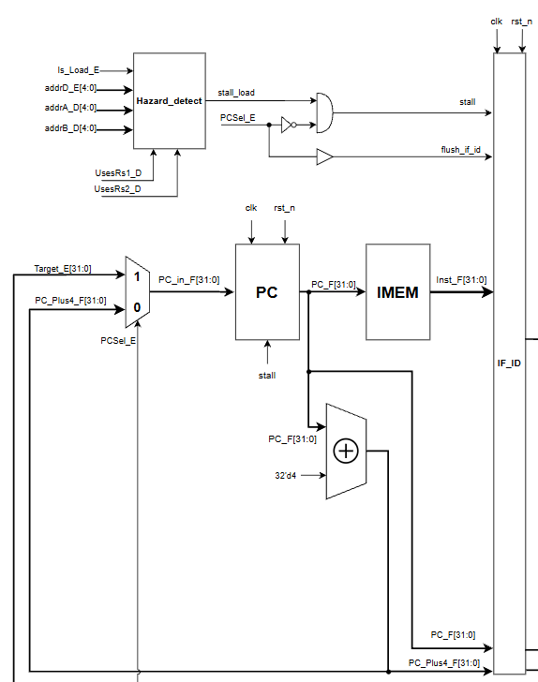
- Fetch State Block Diagram
- IF_ID Register Control Inputs
Port Name | Dir. | Width | Description
clk | Input | 1 | Clock generated by clk_rst_gen.
rst_n | Input | 1 | Active-low reset.
stall | Input | 1 | Holds the current IF/ID contents.
flush_if_id | Input | 1 | Clears the wrong-path instruction from IF/ID.
- IF_ID Register Port Description
Input Source | Output Signal | Width | Description
PC_F | PC_D | 32 | Address of the instruction currently in the Decode stage.
PC_Plus4_F | PC_Plus4_D | 32 | Sequential address after the Decode-stage instruction.
Instr_F | Instr_D | 32 | Complete instruction being decoded.
- IF_ID Register Pipeline Event Behavior
Event | stall | flush_if_id | IF/ID action
Normal execution | 0 | 0 | Capture PC_F, PC_Plus4_F, and Instr_F.
Load-use hazard | 1 | 0 | Hold the existing Decode-stage instruction.
Taken branch | 0 | 1 | Flush the wrong-path instruction.
JAL redirect | 0 | 1 | Flush the wrong-path instruction.
JALR redirect | 0 | 1 | Flush the wrong-path instruction.
Reset | Don’t care | Don’t care | Clear register contents.
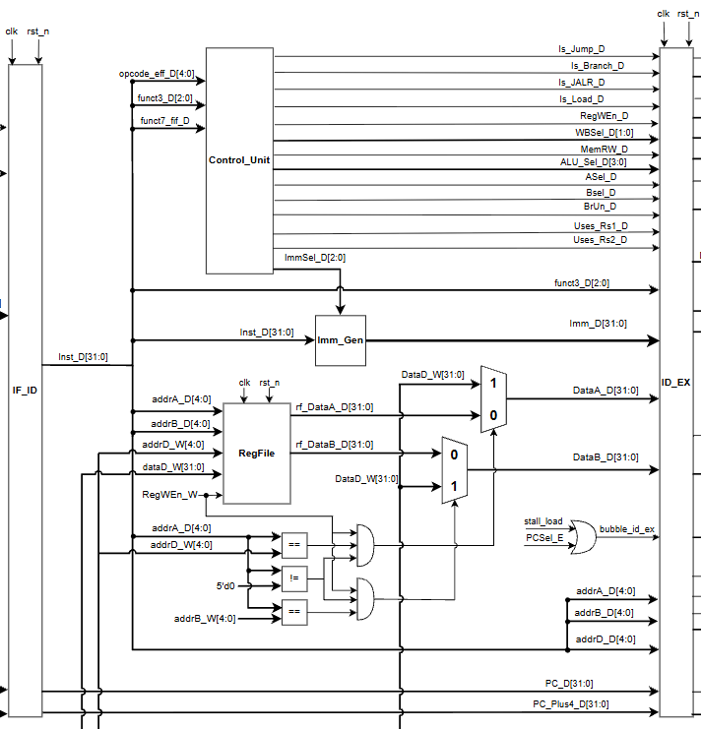
- Decode State Block Diagram
- ID_EX Register Datapath fields
Input Source | Output Signal | Width | Description
PC_D | PC_E | 32 | PC of the instruction in the Execute stage.
PC_Plus4_D | PC_Plus4_E | 32 | Sequential next address for the Execute-stage instruction.
DataA_D | DataA_E | 32 | Original value read from source register rs1.
DataB_D | DataB_E | 32 | Original value read from source register rs2.
Imm_D | Imm_E | 32 | Sign-extended or format-specific immediate.
addrA_D | addrA_E | 5 | Source register address rs1.
addrB_D | addrB_E | 5 | Source register address rs2.
addrD_D | addrD_E | 5 | Destination register address rd.
- ID_EX Register Instruction-decoding fields
Input Source | Output Signal | Width | Description
funct3_D | funct3_E | 3 | Instruction subtype field.
ALUSel_D | ALUSel_E | 4 | Selects the ALU operation.
WBSel_D | WBSel_E | 2 | Selects the eventual writeback source.
ImmSel_D | ImmSel_E | 3 | Immediate-format selection information.
- ID_EX Register and Writeback controls
Input Source | Output Signal | Width | Description
RegWEn_D | RegWEn_E | 1 | Indicates that the instruction intends to write a destination register.
WBSel_D | WBSel_E | 2 | Selects the eventual writeback source.
- ID_EX Register ALU controls
Input Source | Output Signal | Width | Description
ASel_D | ASel_E | 1 | Selects PC or forwarded rs1 as ALU operand A.
BSel_D | BSel_E | 1 | Selects immediate or forwarded rs2 as ALU operand B.
ALUSel_D | ALUSel_E | 4 | Selects the ALU operation.
- ID_EX Register Memory controls
Input Source | Output Signal | Width | Description
MemRW_D | MemRW_E | 1 | Indicates a memory write operation.
Is_Load_D | WBSel_E | 1 | Identifies a load instruction for hazard detection.
- ID_EX Register Branch and Jump controls
Input Source | Output Signal | Width | Description
BrUn_D | BrUn_E | 1 | Selects unsigned rather than signed branch comparison.
Is_Branch_D | Is_Branch_E | 1 | Identifies a conditional branch.
Is_Jump_D | Is_Jump_E | 1 | Identifies a direct jump, normally JAL.
Is_Jump _D | Is_Jump E | 1 | Identifies an indirect JALR jump.
UsesRs1_D | UsesRs1_E | 1 | Indicates that the instruction uses rs1.
UsesRs2_D | UsesRs2_E | 1 | Indicates that the instruction uses rs2.

- ID_EX Register Bubble control
Event | flush_if_id | IF/ID action
Normal execution | 0 | Capture all Decode-stage values and controls.
Load-use hazard | 1 | Insert a bubble into EX.
Taken branch or jump | 1 | Remove the wrong-path Decode-stage instruction.
Reset | Don’t care | Clear register contents.
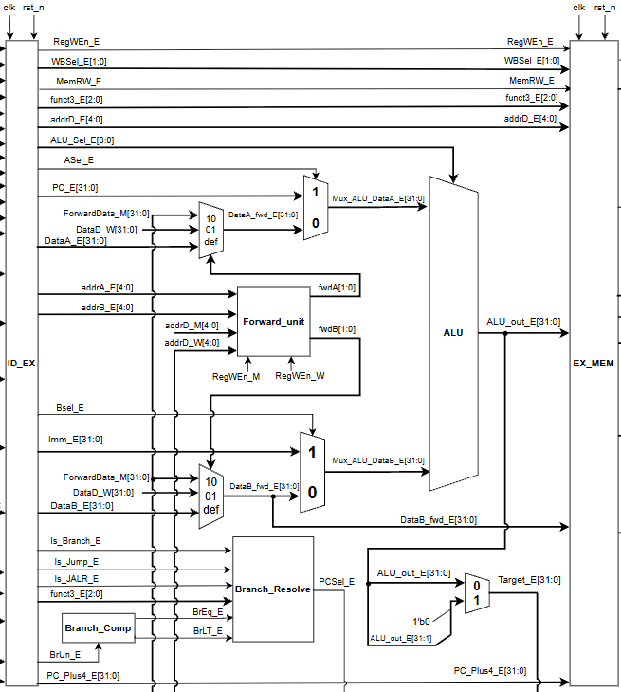
- Execute State Block Diagram
- EX_MEM Register Datapath fields
Input Source | Output Signal | Width | Description
ALU_out_E | ALU_out_M | 32 | ALU result or calculated memory address.
PC_Plus4_E | PC_Plus4_M | 32 | Forwarded rs2 value, used as store data.
DataB_fwd_E | DataB_M | 32 | Sequential next PC for the instruction.
addrD_E | addrD _M | 5 | Destination register address.
WBSel_E | WBSel _M | 2 | Selects the future writeback value.
RegWEn_E | RegWEn _M | 1 | Indicates a future register write.
MemRW_E | MemRW _M | 1 | Enables a data-memory write.
funct3_E | funct3_M | 3 | Specifies load/store width and signedness.
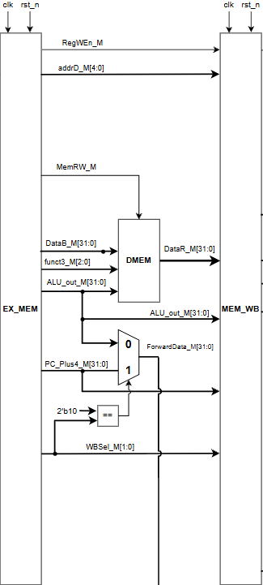
- Memory State Block Diagram
- MEM_WB Register Datapath fields
Input Source | Output Signal | Width | Description
ALU_out_M | ALU_out_W | 32 | ALU result passed to Writeback.
PC_Plus4_M | PC_Plus4_W | 32 | Data returned by data memory.
DataR_M | DataR_M | 32 | Link address for JAL and JALR.
addrD_M | addrD _W | 5 | Destination register address.
WBSel_M | WBSel _W | 2 | Selects the writeback value.
RegWEn_M | RegWEn _W | 1 | Enables writing to the register file.
- MEM_WB Register Writeback selection
WBSel_W | Selected value | Instruction category
2’b00 | DataR_W | Capture all Decode-stage values and controls.
2’b01 | ALU_out_W | Insert a bubble into EX.
2’b10 | PC_Plus4_W | Remove the wrong-path Decode-stage instruction.
2’b11 | Zero/Default | Clear register contents.
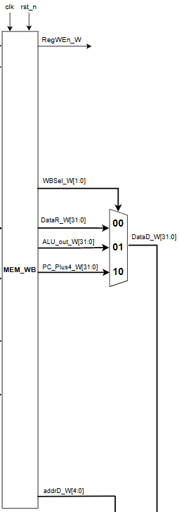
- Write Back State Block Diagram
- MEM_WB Register Port Description
Port Name | Direction | Width | Description
RegWEn_W | Output | 1 | Enables writing to the register file.
WBSel_W | Output | 2 | Selects the writeback value.
DataR_W | Output | 32 | Data returned by data memory.
ALU_out_W | Output | 32 | ALU result selected for RegFile.
PC_Plus4_W | Output | 32 | Link address for JAL and JALR.
addrD_W | Output | 5 | Destination register address.
DataD_W | Internal Reg | 32 | Mux data writeback to RegFile.

2.2. Automated Verification Functional Diagram
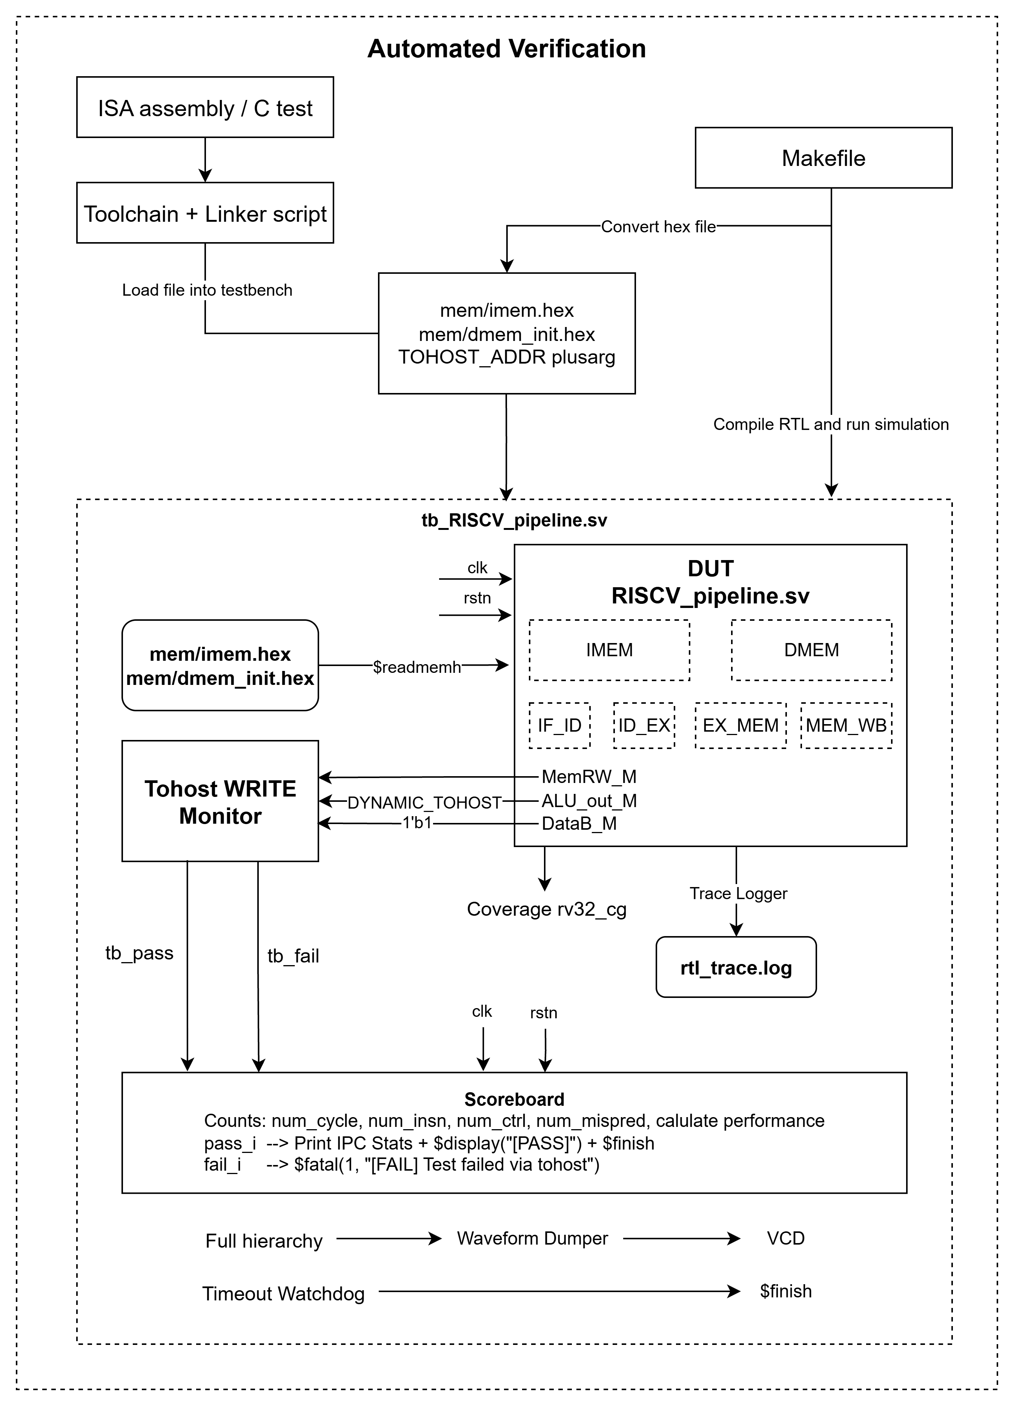
- Automated Verification Functional Diagram
• The Makefile compiles the RTL design and testbench, converts the assembly or C program into HEX files, passes the TOHOST_ADDR, and launches the simulation.
• The testbench generates the clock and active-low reset, then loads imem.hex and dmem_init.hex into the DUT memories using $readmemh.
• The pipelined RISC-V DUT executes the test program through the IF, ID, EX, MEM, and WB pipeline stages.
• The tohost write monitor observes MemRW_M, ALU_out_M, and DataB_M to detect program completion and generate the tb_pass or tb_fail signal.
• The scoreboard receives the clock, reset, pass, and fail signals, calculates performance statistics, reports the test result, and terminates the simulation.
• The functional coverage collector samples instruction types, destination registers, and RAW hazards under valid, non-stalled pipeline conditions.
• The trace logger records valid register write-back events in rtl_trace.log for debugging and result comparison.
• The waveform dumper records the complete testbench hierarchy in RISCV_Pipeline.vcd, while the timeout watchdog stops simulations that exceed the allowed execution time.
- Testbench Top-Level Port Description
Module | Input ports | Output ports | Description
tb_RISCV_Pipeline | None | None | Top-level verification module that generates clock and reset, initializes memories, monitors program completion, collects coverage, logs execution, and controls simulation termination.
- Testbench File Input/Output Description
File/Resource | Direction | Producer | Consumer | Description
mem/imem.hex | Input to simulation | Toolchain/Makefile | DUT instruction memory | Program instruction memory image.
mem/dmem_init.hex | Input to simulation | Toolchain/Makefile | DUT data memory | Initial data memory image.
+TOHOST_ADDR=<hex> | Input to simulation | Makefile/simulation command | Tohost Monitor | Runtime tohost-address configuration.
rtl_trace.log | Output from simulation | Trace Logger | Verification/debug flow | Register write-back trace.
RISCV_Pipeline.vcd | Output from simulation | Waveform Dumper | Waveform viewer | Full testbench and DUT waveform database.

2.3. Testbench Signal and Register Table
(Use this table for verification-visible control/status locations. Replace placeholder addresses with the real course memory map or final testbench constants.)
- Testbench Signal and Register Description
Name | Type | Access | Reset | Description
clk | logic | 1 bit | Initialized to 0 | Testbench-generated clock. It toggles every 5 time units.
rstn | logic | 1 bit | Initialized to 0, set to 1 after 20 time units | Active-low reset signal connected to the DUT and scoreboard.
tb_pass | logic | 1 bit | Cleared at every positive clock edge | One-cycle pass pulse generated by the tohost write monitor.
tb_fail | logic | 1 bit | Cleared at every positive clock edge | One-cycle failure pulse generated by the tohost write monitor.
DYNAMIC_TOHOST | integer | Typically 32 bits | Defaults to 32'h00001300 | Runtime-configurable address used to detect writes to the tohost location.
trace_fd | integer | Simulator-dependent | Assigned by $fopen | File descriptor for rtl_trace.log.
prev_rd | logic[4:0] | 5 bits | Not explicitly reset in the current code | Stores the previous valid write-back destination register for RAW hazard coverage.
current_opcode | logic[6:0] | 7 bits | Combinationally assigned | Opcode extracted from the decode-stage instruction.
current_rs1 | logic[4:0] | 5 bits | Combinationally assigned | First source-register index extracted from the decode-stage instruction.
current_rs2 | logic[4:0] | 5 bits | Combinationally assigned | Second source-register index extracted from the decode-stage instruction.
cg_inst | rv32_cg object | Not applicable | Created using new() | Instance of the functional coverage group.

Module Specifications

3.1. RISC-V Pipeline DUT
- RISCV_pipeline DUT Port Description
Port name | Direction | Width | Connected Signal | Description
clk | Input | 1 bit | clk | Main DUT clock. The testbench toggles the clock every 5 time units, producing a period of 10 time units.
rst_n | Input | 1 bit | rstn | Active-low DUT reset. The testbench holds reset low for 20 time units before releasing it.

3.2. Scoreboard
- Scoreboard Port Description
Port name | Direction | Width | Connected Signal | Description
i_clk | Input | 1 bit | clk | Main DUT clock. The testbench toggles the clock every 5 time units, producing a period of 10 time units.
i_reset | Input | 1 bit | rstn | Active-low DUT reset. The testbench holds reset low for 20 time units before releasing it.
pass_i | Input | 1 bit | tb_pass | One-cycle pulse indicating that the DUT wrote the passing value to the tohost address.
fail_i | Input | 1 bit | tb_fail | One-cycle pulse indicating that the DUT wrote a non-passing value to the tohost address.

3.3. Tohost WRITE Monitor Interface
- Tohost WRITE Monitor Interface Port Description
Signal | Direction | Width | Source/Destination | Description
clk | Input | 1 bit | Testbench clock generator | The monitor performs checking on every positive clock edge.
rstn | Input | 1 bit | Testbench reset generator | Enables completion checking when reset is released.
dut.MemRW_M | Observed input | 1 bit | DUT memory stage | Indicates that the current memory-stage operation is a memory write.
dut.ALU_out_M | Observed input | Expected 32 bits | DUT memory stage | Memory address generated by the DUT. It is compared with DYNAMIC_TOHOST.
dut.DataB_M | Observed input | Expected 32 bits | DUT memory stage | Store data. A value of 32'h00000001 indicates a passing test.
DYNAMIC_TOHOST | Configuration input | 32 bits in current usage | Testbench plusarg configuration | Address used by the monitor to identify a tohost write.
tb_pass | Output | 1 bit | scoreboard.pass_i | Asserted for one clock cycle when the DUT writes 32'h1 to DYNAMIC_TOHOST.
tb_fail | Output | 1 bit | scoreboard.fail_i | Asserted for one clock cycle when the DUT writes a value other than 32'h00000001 to DYNAMIC_TOHOST.
- Tohost Decision Behavior
rstn | MemRW_M | Address Comparison | DataB_M | Result
0 | X | X | X | Monitor inactive.
1 | 0 | X | X | No tohost event.
1 | 1 | ALU_out_M != DYNAMIC_TOHOST | X | Normal memory write.
1 | 1 | ALU_out_M == DYNAMIC_TOHOST | 32'h00000001 | Assert tb_pass.
1 | 1 | ALU_out_M == DYNAMIC_TOHOST | Any other value | Assert tb_fail.
- Tohost Configuration Description
Configuration item | Type | Default | Source | Description
DYNAMIC_TOHOST | integer | 32'h00001300 | Testbench variable | Active tohost address used by the monitor.
TOHOST_ADDR=<hex> | Simulator plusarg | Not applicable | Makefile or simulation command | Overrides the default value of DYNAMIC_TOHOST.
TOHOST_ADDR | localparam | 32'h00000300 | Testbench constant | Declared in the earlier code but not used by the visible tohost monitor.

3.4. Memory Initialization Interface
- Memory Initialization Interface Input File Description
Input file | Destination | Operation | Description
./mem/imem.hex | dut.IMEM_inst.memory | $readmemh | Initializes the DUT instruction memory before program execution.
./mem/dmem_init.hex | dut.DMEM_inst.memory | $readmemh | Initializes the DUT data memory before program execution.

Trace Logger Interface
- Trace Logger Interface Input Signals Description
Signal | Width | Source | Description
clk | 1 bit | Testbench | Trace sampling clock.
rstn | 1 bit | Testbench | Enables trace collection after reset.
dut.RegWEn_W | Expected 1 bit | DUT write-back stage | Indicates that the instruction writes a destination register.
dut.addrD_W | 5 bits | DUT write-back stage | Destination register index.
dut.DataD_W | Expected 32 bits | DUT write-back stage | Data written to the destination register.
dut.PC_Plus4_W | Expected 32 bits | DUT write-back stage | Used to calculate the instruction PC as PC_Plus4_W - 4.
- Trace Logger Output Description
Output | Type | Description
rtl_trace.log | Text file | Contains the PC, destination register, and register write-back data for each committed register-writing instruction.
- Trace Logger File-descriptor
Variable | Type | Width | Description
trace_fd | integer | Simulator-dependent | File descriptor returned by $fopen("rtl_trace.log", "w").

3.6. Functional Coverage
- Functional Coverage Signal Purpose
Signal or Variable | Width | Source | Coverage Purpose
clk | 1 bit | Testbench | Covergroup sampling event occurs at each positive clock edge.
rstn | 1 bit | Testbench | Disables sampling while reset is asserted.
dut.Instr_D | 32 bits | DUT decode stage | Supplies the opcode, rs1, and rs2 fields.
dut.addrD_D | 5 bits | DUT decode stage | Destination-register coverage.
dut.RegWEn_D | 1 bit | DUT decode stage | Qualifies destination-register sampling.
dut.bubble_id_ex | 1 bit | DUT pipeline control | Prevents coverage sampling for pipeline bubbles.
dut.stall_load | 1 bit | DUT hazard unit | Prevents sampling while the pipeline is stalled by a load-use hazard.
dut.RegWEn_W | 1 bit | DUT write-back stage | Qualifies updates to prev_rd.
dut.addrD_W | 5 bits | DUT write-back stage | Supplies the previous destination register.
prev_rd | 5 bits | Testbench register | Used to detect a back-to-back RAW dependency on rs1.
- Coverage-derived Field Description
Variable | Width | Source Expression | Description
current_opcode | 7 bits | Decode instruction bits [6:0] | Current instruction opcode.
current_rs1 | 5 bits | Decode instruction bits [19:15] | Current instruction source register 1.
current_rs2 | 5 bits | Decode instruction bits [24:20] | Current instruction source register 2.
- Functional Coverage Point Description
Coverpoint | Sampled Value | Qualification | Description
cp_opcode | current_opcode | Reset released, no ID/EX bubble, and no load stall | Measures execution of major RV32 instruction categories.
cp_dest_reg | dut.addrD_D | Valid decode instruction, no load stall, and RegWEn_D asserted | Measures use of destination registers x1 through x31.
cp_raw_hazard_rs1 | Comparison between current_rs1 and prev_rd | Reset released, valid decode instruction, and no load stall | Measures no-hazard and back-to-back RAW-hazard cases involving rs1.
- Opcode Coverage Bins
Bin Name | Opcode | Covered Instruction Class
alu_r_type | 7'b0110011 | Register-register ALU instructions
alu_i_type | 7'b0010011 | Immediate ALU instructions
loads | 7'b0000011 | Load instructions
stores | 7'b0100011 | Store instructions
branches | 7'b1100011 | Conditional branch instructions
u_types | 7'b0110111, 7'b0010111 | LUI and AUIPC
jumps | 7'b1101111, 7'b1100111 | JAL and JALR

3.7. Previous Destination Register
- Previous Destination Register Description
Register | Width | Update Condition | Next Value | Description
prev_rd | 5 bits | Reset released, write-back enabled, and destination register is not x0. | dut.addrD_W | Stores the most recent valid write-back destination for RAW hazard detection.

3.8. Hierarchical Monitored DUT Signals
- Hierarchical Monitored DUT Signals Description
DUT Signal | Width | Pipeline Stage | Used by | Description
MemRW_M | 1 bit | Memory | Tohost Monitor | Memory-write control signal.
ALU_out_M | 32 bits | Memory | Tohost Monitor | Store address compared against the tohost address.
DataB_M | 32 bits | Memory | Tohost Monitor | Store data used to determine test pass or failure.
RegWEn_W | 1 bit | Write-back | Trace Logger, prev_rd tracker | Indicates valid register write-back.
addrD_W | 5 bits | Write-back | Trace Logger, prev_rd tracker | Destination register index.
DataD_W | 32 bits | Write-back | Trace Logger | Register write-back data.
PC_Plus4_W | 32 bits | Write-back | Trace Logger | Used to reconstruct the committed instruction PC.
Instr_D | 32 bits | Decode | Functional coverage | Current decode-stage instruction.
addrD_D | 5 bits | Decode | Functional coverage | Decode-stage destination register.
RegWEn_D | 1 bit | Decode | Functional coverage | Indicates that the decoded instruction writes a register.
bubble_id_ex | 1 bit | Pipeline control | Functional coverage | Indicates an invalid or bubble condition.
stall_load | 1 bit | Hazard control | Functional coverage | Indicates a load-use pipeline stall.

3.9. Simulation Control
- Simulation Control Behavior
Control Function | Trigger | Result
Clock generator | Simulation start | Generates a 10-time-unit clock period.
Reset generator | Simulation start | Holds active-low reset for 20 time units.
Memory loader | Simulation start | Loads IMEM and DMEM hex files.
Pass termination | tb_pass asserted | Scoreboard prints statistics and calls $finish.
Failure termination | tb_fail asserted | Scoreboard calls $fatal.
Timeout watchdog | Simulation reaches #100000 | Prints a timeout message and calls $finish.
Waveform dumping | Simulation start | Creates RISCV_Pipeline.vcd and dumps the full hierarchy.

Verification Strategy

5.1. Regression Flow
- Build assembly test into HEX.
- Run the same test on the single-cycle DUT.
- Run the same test on the pipelined DUT.
- Capture logs, waveforms, and final status.
- Compare architectural results, counters, and pipeline-specific events.
- Write one regression summary row per DUT and test case.

5.2. Verification Matrix
- Verification Matrix
Feature | Example Tests | Checked Result | Single-Cycle | Pipeline | Coverage Target
ALU | ADD, SUB, SLT, SLTU | rd value, x0 behavior | Yes | Yes | All ALU ops
Logic/Shift | AND, OR, XOR, SLL, SRL, SRA | rd value and sign behavior | Yes | Yes | All shift amounts
Immediate | ADDI, SLTI, ORI, LUI, AUIPC | sign-extension and PC-relative result | Yes | Yes | Boundary immediates
Load/Store | LB/LH/LW/LBU/LHU, SB/SH/SW | memory data, byte enables | Yes | Yes | Aligned and selected boundary cases
Branch | BEQ, BNE, BLT, BGE, BLTU, BGEU | taken/not-taken PC | Yes | Yes | Both outcomes
Jump | JAL, JALR | link register and target PC | Yes | Yes | Forward/backward
Src/Dst Cases | rs1=rd, rs2=rd, rs1=rs2, rd=x0 | correct dependency behavior | Yes | Yes | All key patterns
Hazards | Forwarding, load-use, load-branch | stall, forward, flush | N/A | Yes | Each hazard class
Misaligned Access | negative or defined response test | expected behavior | Optional | Yes | At least one per type

5.3. Coverage Plan
- Instruction coverage: each implemented RV32I instruction is executed at least once.
- Operand coverage: zero, positive, negative, maximum, minimum, random-like values, and x0-related cases.
- Register dependency coverage: source equals destination, source registers equal each other, and write to x0 cases.
- Memory coverage: byte, halfword, word access, read/write direction, boundary address, and selected misaligned cases.
- Pipeline coverage: forwarding source, stall reason, flush reason, branch prediction outcome, and misprediction recovery.

PASS/FAIL Criteria

6.1. PASS Criteria
- Simulation finishes before timeout.
- The expected tohost PASS signature is reached.
- Register write-back, memory read/write, PC updates, branch/jump behavior, and final data memory state match expected results.
- For the pipelined DUT, forwarding, stalls, flushes, misprediction events, and misaligned memory access behavior match expected behavior.
- No unknown X/Z values are observed on critical checked signals during active checking.
- Regression summary reports PASS for all required tests or clearly identifies waived optional tests.

6.2. FAIL Criteria
- Any expected-vs-actual mismatch in architectural state.
- Timeout, missing completion signature, or unexpected fatal condition.
- Incorrect reset behavior or incorrect instruction memory loading.
- Unknown X/Z value on critical checked signals.
- Pipeline-specific mismatch such as missing forwarding, incorrect stall duration, wrong flush, wrong PC recovery, or unexpected misaligned access result.
- Injected RTL bug changes observable behavior but is not detected by existing checks.

Result
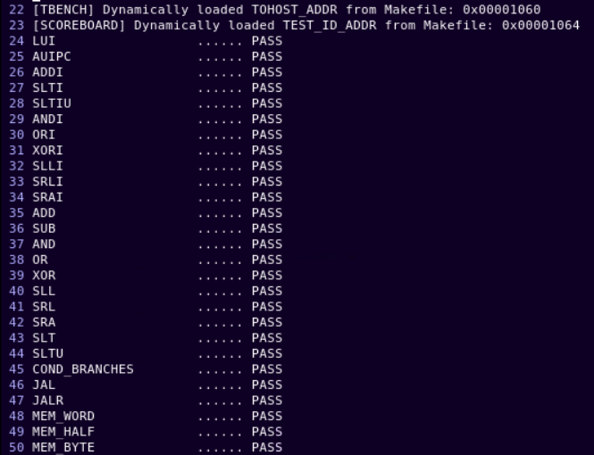
- Testbench PASS Result Simulation Log (1)
Figure 8 shows the automated verification results for the pipelined RISC-V processor. The testbench dynamically loads the TOHOST_ADDR and TEST_ID_ADDR values from the Makefile, then executes a set of ISA tests covering arithmetic, logical, shift, comparison, branch, jump, and memory-access instructions. All displayed tests report PASS, indicating that the DUT correctly executes the tested RV32 instructions and that the automated testbench successfully detects and reports each test result.
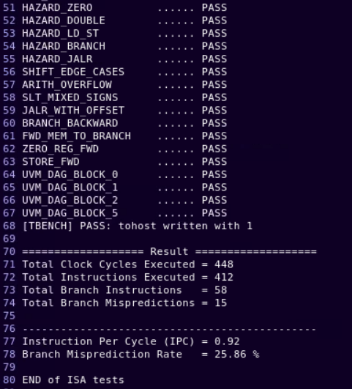
- Testbench PASS Result Simulation Log (2)
Figure 9 presents the remaining automated verification results, including pipeline hazards, forwarding paths, branch and jump corner cases, arithmetic edge cases, and directed UVM tests. All test cases report PASS, and the final write of 1 to the tohost address confirms successful program completion. The scoreboard reports 448 clock cycles, 412 executed instructions, 58 branch instructions, and 15 branch mispredictions, resulting in an IPC of 0.92 and a branch misprediction rate of 25.86%.
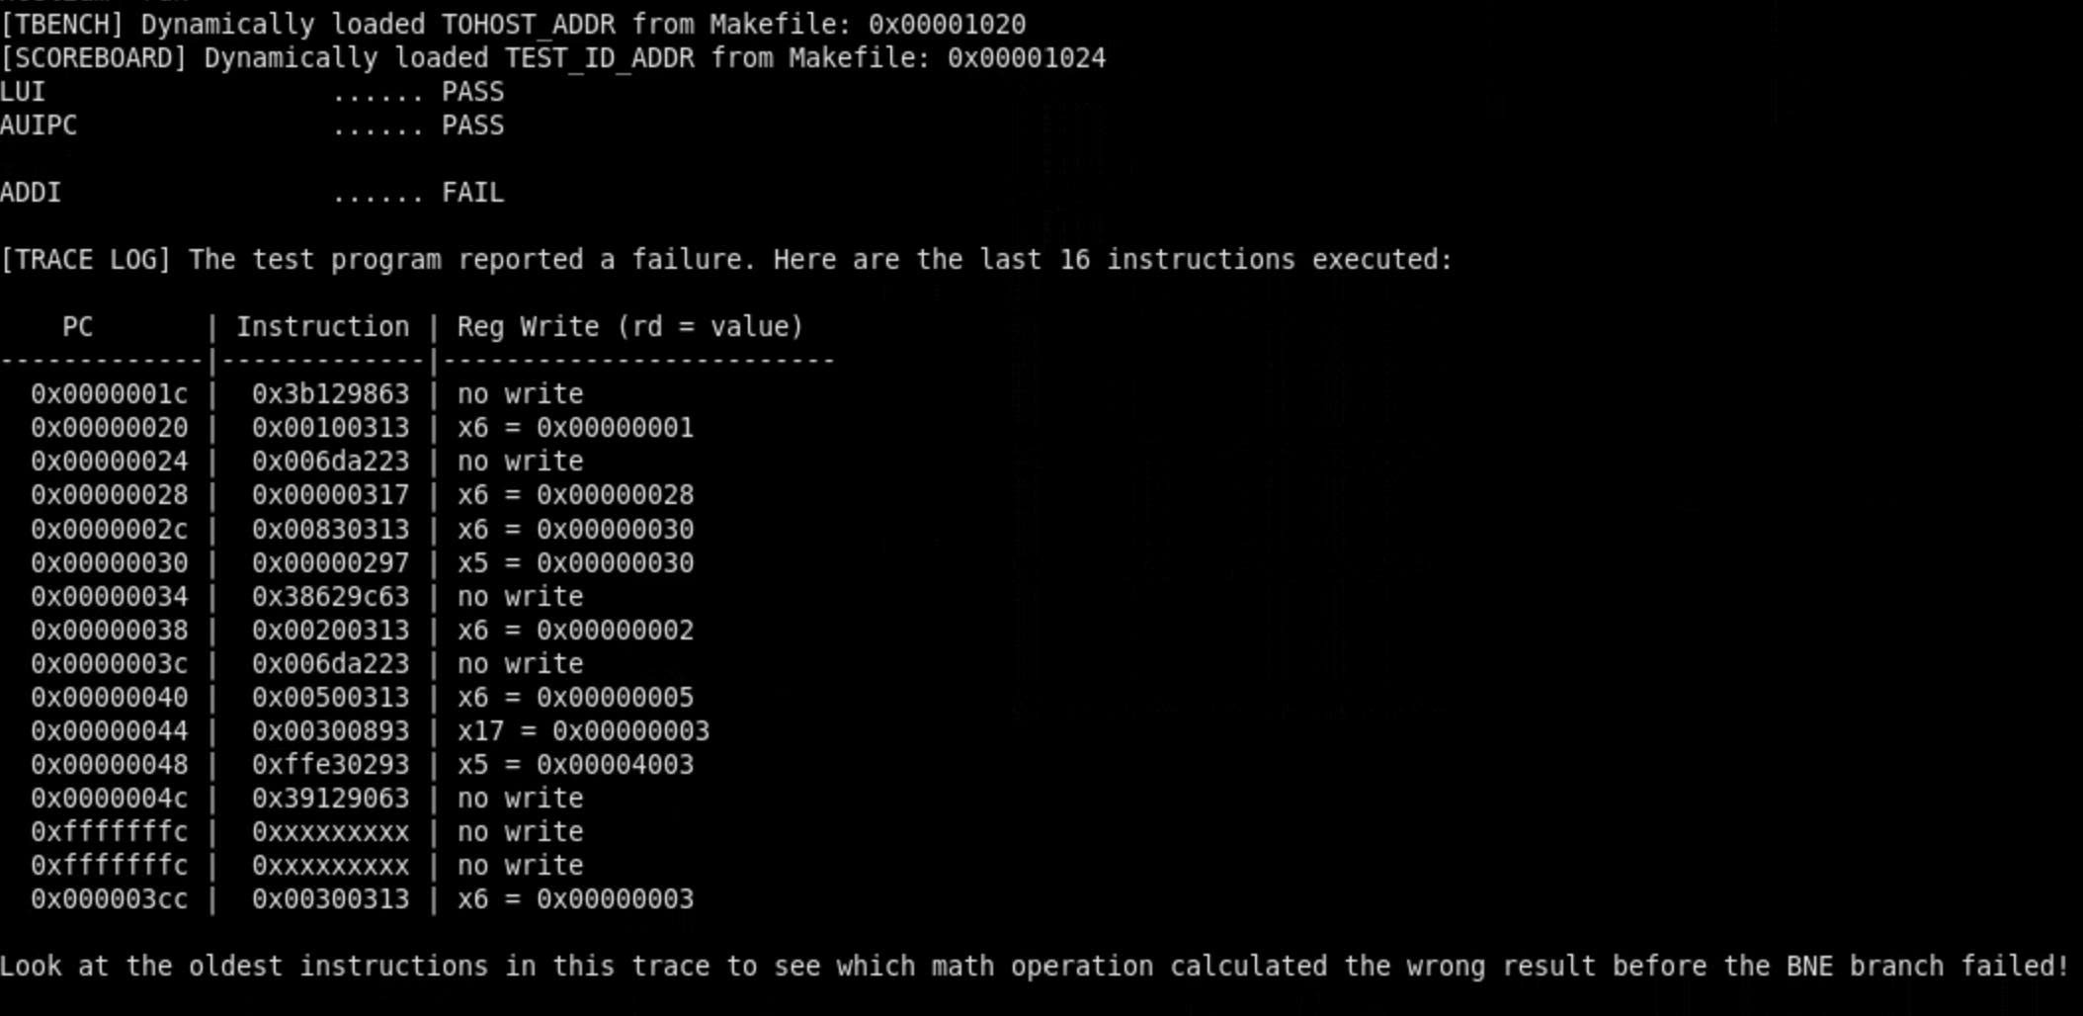
- Testbench FAIL Result Simulation Log
Figure 10 demonstrates the automated verification environment’s failure-detection and debugging capability. After dynamically loading the TOHOST_ADDR and TEST_ID_ADDR, the testbench reports that the LUI and AUIPC tests pass, while the ADDI test fails. In response, the verification system automatically displays a trace of the last 16 executed instructions, including the program counter, instruction encoding, destination register, and write-back value. This trace helps identify the earlier arithmetic operation that produced an incorrect result before the subsequent BNE branch detected the failure.

Deliverables
- Full specification document with finalized port tables, register offsets, module descriptions, FSMs, and waveform evidence.
- SystemVerilog testbench and verification components.
- Makefile and optional script files for single-test and regression execution.
- Directed ISA tests and compact bug-detection test programs.
- Regression summary including PASS/FAIL, instruction count, cycle count, IPC, control instruction count, branch misprediction count, mismatch logs, coverage summary, and waveform paths.
- Final demo package and presentation slides.

References
- Andrew Waterman, Yunsup Lee, David A. Patterson, and Krste Asanović, (May 13, 2011). “The RISC-V Instruction Set Manual”. EECS Department, University of California, Berkeley.
- Chris Spear, (June 5, 2008). “SystemVerilog for Verification: A Guide to Learning the Testbench Language Features”. Springer.
- David A. Patterson, John L. Hennessy, (December 4, 2020). “Computer Organization and Design: The Hardware/Software Interface”. Morgan Kaufmann.
- Luciano Lavagno, Grant E. Martin, Igor L. Markov, and Louis K. Scheffer, (2016). “Electronic Design Automation for IC System Design, Verification, and Testing”. CRC Press.
- VNCHIP Institute of Semiconductor Research and Development, (2026). “VNCHIP RISC-V Computer Structure Lab6 manual”.
- VNCHIP Institute of Semiconductor Research and Development, (2026). “VNCHIP RISC-V Computer Structure Lab7 manual”.

